Business Proposal

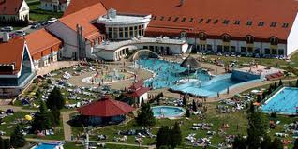

Kehida Termál Health Resort and Family Spa

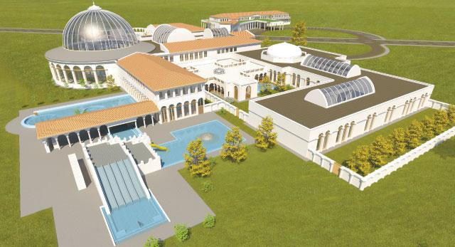

Zalacsány Golf Courses

Only 5 minutes away

An idea

An excellent business opportunity now...

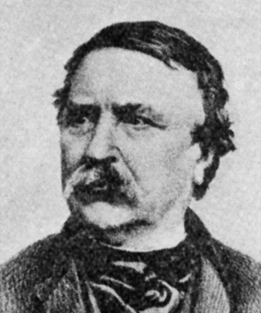

Kehidakustány 15-02-2013 Drawn up by: István Garami

Current Situation

  - Setting:

The Kehida Gold Ltd investment was realized in 2002. Its suites and its restaurant opened at the same time with Kehida Termál Health Resort. Kehida Gold soon became very popular, gaining a steady clientele, so the company kept getting stronger.

Its current owner is forced to part with his business due to his health problems, so he decided to sell it. In case the new owner requires, there are some amongst the current staff who would be happy to undertake take the managerial responsibilities of the business.

Further possibilities are elaborated below.

1.2. Economic and Social Circumstances

1.2.1. Kehidakustány
The small town of 1076 inhabitants lies on the banks of Zala River, among green hills of grapevines and woods. The gorgeous, hilly landscape, the idyllic serenity of the countryside and the spa utilizing the 43 ºC thermal water became a popular hiking and resort destination for many people. Those looking for other activities can enjoy fishing, hunting, horse-riding, biking and hiking in and around the town.
From 1824, here lived Ferenc Deák, the attorney general of the first independent Hungarian government and the key figure of the passive defiance after the war for independence. Today, this mansion, his former home is a museum, holding a constant exhibition since 2004.

The town’s cemetery features the ancient church of the settlement, built in the 13th century, which later became the tomb of the Deák family. Today it functions as a chapel. On the main street of Kustány stands the traditional wooden bellfry, an excellent example of the Zala county folklore architecture. The bell is still tolled manually. The small town’s income has been solely based on agricultural products until the exploration of thermal water in 1980, which entirely changed the life of the community. The spa became more and more popular among both Hungarians and foreigners.
The tourism developed quickly in Kehidakustány from 2002, when the Kehida Termál Health Resort and Family Spa opened. This part of the countryside is being constantly developed since. 60% of the visitors are domestic, 40% are foreigners, mainly from Austria, Germany, Slovakia and the Czech Republic. 35% of the visitors come looking for remedy.

The adjoining town, Zalacsány gives home to the biggest investment of 2013-14 in the area; golf courses and their utility buildings are being built all the way from the Batthyány Manor Wellness Hotel to Kehida Termál Spa.
The plans include golf courses (18 holes within 2 years), central golf club buildings, pools and other services. (The whole investment is to be realized until 2016.)

1.2.2. Economy and Society:

The small town has 1076 inhabitants.
Due to the development of health tourism, the population has been greatly increased recently. The extensive development of the thermal health resort and spa brought an increase in the town’s population by 150%.
Tourism became a primary source of income for Kehidakustány, so almost half of the businesses in the area work within the tourism industry offering accommodation and other associated services.

The more developed forms of health tourism are not yet present in the area, so there are many unutilized opportunities still (dental services for example). These opportunities are even more lucrative considering the vicinity of Sármellék Airport and more than one border.

1.2.3. Tourist Destinations In and Around Town:

The almost unmarred natural environment’s most important tourist destination is the Kehida Termál Health Resort and Family Spa. The spa, covering four acres, is very popular, since it’s close to Balaton and Hévíz Lakes, the borders of Croatia, Slovenia and Austria are not far either, and the Zala valley has an exceptionally calm and comfortable climate. Due to the beautiful and functional spa complex and the high quality medicinal water more and more domestic and foreign visitors arrive to town, spending some time here.
The medicinal water of Kehidakustány has and equally good quality of that of the world-famous Hévíz thermal lake. The water is an ideal remedy for locomotor and rheumatic diseases, and it’s also excellent for ailments of the nervous system. The water in the thermal spa pools is between 34°C and 42°C.
The Ferenc Deák manor: The manor was built in the 18th century by the influential Zala county family, the Hertelendys. It was given to Ferenc Deák’s father as an heirloom. Ferenc Deák also lived here for quite a long time. His friends, also key figures of the era’s cultural and political pantheon, like László Csány, Mihály Vörösmarty, Miklós Wesselényi, Istvány Széchenyi and Lajos Batthyányi. Deák sold the manor to the Széchenyis in 1854, and later it became a property of the Károlyis. In 1925, the government bought it and founded an agricultural school near the main building. There’s a bulk of Ferenc Deák in front of the manor, made by the sculptor György Zala in 1925. The manor is typical gentry country house, its 1.5 acre park is under national protection.
Tomb chapel. Romanian origin, built in the 13th century. Later it was transformed to the tomb of the Deák family.
Roman catholic church. Historical landmark, built in 1756. It has a copf style pulpit.
Annual Events: Kehidai Kavalkád (Festival) at Easter, Equestrian Termál Cup in August and Deák Days in mid-October.

The town lies in the middle of the ’Thermal-way’: Zalaszentgrót 15 kms, Zalaegerszeg 25 kms, Zalakaros 25 kms, Hévíz 10 kms, Sármellék Airport 15 kms.

Tourist attractions in nearby towns and villages:
There are several tourist destinations in the Kehidakustány area. These attractions and landmarks are only a 15-30 minute ride away:
- Kis-Balaton Lake and Zalavár nature reserve
- Zalaszentgrót Thermal Spa and Batthyányi Manor
- Badacsony Wine Region
- Zalacsány fishing lake and sport centre
- Buddhist Stupa at Zalaszántó
- Zalaegerszeg Aquacity, Göcsej Skanzen, Csács Botanic Gardens and Azalea valley
- Africa Museum in Balatonederics
- ’Szépkilátó’ Look-out Tower at Balatongyörök
- Buffalo Reserve at Kápolnapuszta
- Festetics Hall, Georgikon Museum, Marzipan Museum at Keszthely
- Round Temple at Kallósd
- Thermal Spa at Hévíz
- Sármellék Airport

1.2.4. Transportation:

The Western Transdanubian region’s transportation network is quite even. The region is crossed by two motorways (M1 and M7), from where the bigger cities and towns are easy to reach on main roads (nos. 84, 85, 86, 74, 75 and 76). Smaller towns and villages are accessible by minor roads.

Transportation by train is not even, since it mostly includes the bigger towns, but it usually skips the smaller towns and villages. It is an unfortunate trend that smaller villages can only be reached by combined transportation (trains and buses).

Air transportation is supported by Sármellék Airport. The airport, which is classified as a permanent, not public, temporarily open border customs airport (category C), is currently operated by Hévíz local authority. The airport is open for public charters since 1993. The annual passenger count was 8600 in 1996. The airport also supports sail-planes, gliders, hot-air balloons and skydiving.

1.2.5. The Zalaszentgrót Region

The region’s main attractions are the natural environment, the traditional events, the thermal spas built in the Zala valley, and the preservation of cultural and historical heritage. The region’s outstanding bio-diversity is due to its rich water network and water habitats. Its climate and soil are excellent bases for forestry and wildlife management. The special products of the region include traditional handcrafted products and associated cultural events.

1.3. Demand and Supply:

The Kehidakustány thermal water is certified medicinal water, classified as a calcium-magnesium hydrogen-carbonate water of the sulphurous medicinal waters. It is an excellent remedy for or prevention against gynaecological, dermatological and locomotor problems, or the ailments of the nervous system. It is also used for post-traumatic rehabilitation therapy, since the medicinal water accelerates the healing process of broken bones and severe wounds.
Those looking for an active pastime can find a fitting program for themselves. The town offers opportunities of fishing, hunting, horseback-riding, biking and hiking.

The commercial accommodations are completely booked up during the tourist season, the spring and autumn breaks and the long bank holiday weekends, especially in Kehidakustány because of the thermal spa. The autumn is more popular among the foreign tourists, who usually stay for a 4-5 days.

Kehida Gold Ltd. operates its own restaurant called ’Vándorbab’ and its suites in Kehidakustány. The business has a steady clientele of more and more returning guests every year. Our business is very popular because of the cosy, family atmosphere and the mutual trust and friendships we formed with our guests during these past years.

2. Possibilities

There’s an option to extend the current scope of services or implement further developments of the business. This would be a very lucrative idea, since further services are definitely needed when the close-by golf courses open and generate another kind of clientele, who would probably require three star accommodation.

This would obviously mean more services. (There are several possibilities to develop the current business by further construction, rental or purchase.)

Also, our current clientele would happily pay for these extra services.

Our complex consists of 12-18 high quality suite units (4-4 suites in 4 separate buildings, and 2 further suites in another building, where one of the suites is specifically built to accommodate disabled guests), a well-equipped restaurant with an extra parlour, and other services (for example a Relax Studio). Please visit our website for further information at www.vandorbab.hu. The whole complex can also be run profitably as it is without any changes.

Sale Price: 199 million Forints (for 12 suites + a restaurant, which cover an almost 1000 square metres built-up area). It is also possible to purchase the company itself, since most of the buildings are owned by the company, so you can save money on dues and fees.
For further information please call István Garami at +36 20 9242 855.

Semi-detached house – Kehidakustány
4 units of 75 m² suites on a plot of 720 m², plus a garage

14 Malombokrai Street, Kehidakustány

A house in Kehidakustány, 800 ms from the thermal spa, on a plot of 720 m² with all public utilities, built in 2002. There are 4 separate flats in the building; all of them are 75 m². They have the same layout including the following rooms: living room (16 m²), bedroom (13 m²), kitchen + dining room (16 m²), bathroom, toilet, corridor, larder. There are balconies upstairs and terraces downstairs. The house has gas heating, with separate boilers and radiators in each flat. There’s a garage for 2 cars in the garden. The house can serve as a home for a big family of different generations or it would be a great business opportunity to rent the suits.

Property Details:
Property type: | multi-flat building | Area (m²): | 300
Ownership: | private property
Building type: | semi-detached house | Construction material: | brick
Heating: | central (boilers) | Conveniences: | self-contained
Furniture: | upon request | Property condition: | good
Building condition: | good | Water: | yes – own meter
Electricity: | yes | Gas: | yes – own meter
Sewage: | yes | Floors: | 2 (ground, first)
Plot size (m²): | 720 | Flats: | 4
Year of construction: | 2002 | Rooms: | 8

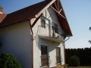

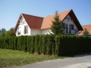

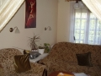

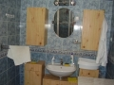

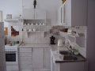

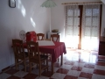

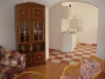

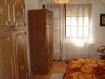

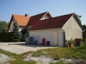

garage

’Vándorbab’ Restaurant

Built in 2002, consists of ground floor dining rooms, a bar, an upstairs room and utility rooms.
Includes a fully equipped, HACCP system kitchen.

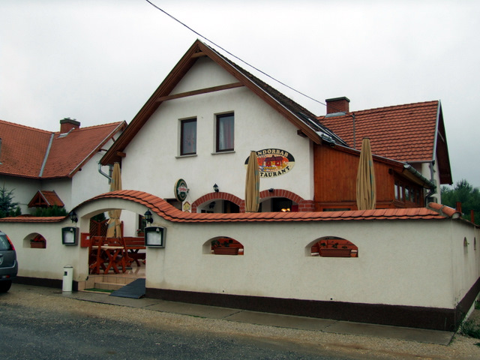
’Vándorbab’ Restaurant exterior

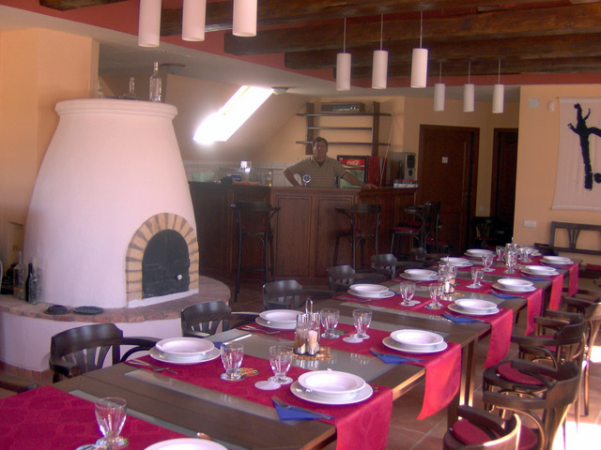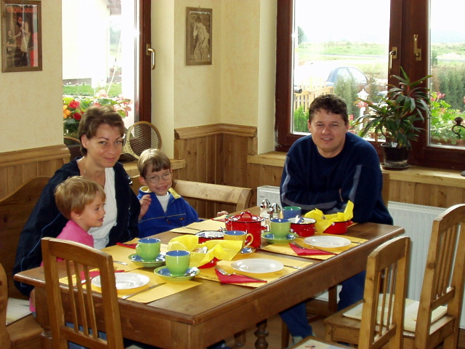
’Vándorbab’ Restaurant first floor parlour and ground floor dining room

SUITES

2x4 suites in 190 m² buildings on 2 separate 720 m² plots

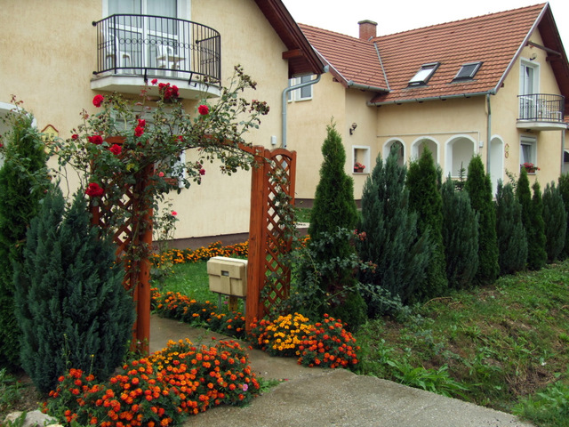
’Vándorbab’ Suite buildings

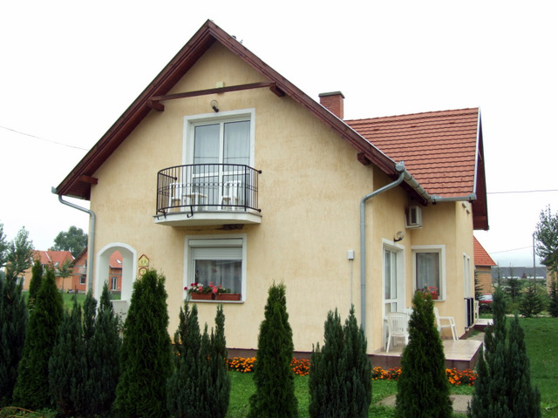
’Vándorbab’ Suite building

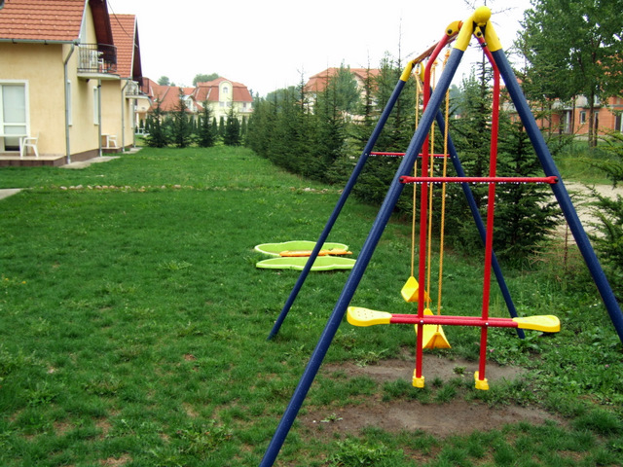
’Vándorbab’ Suite buildings’ back yard with parking spaces and a playground

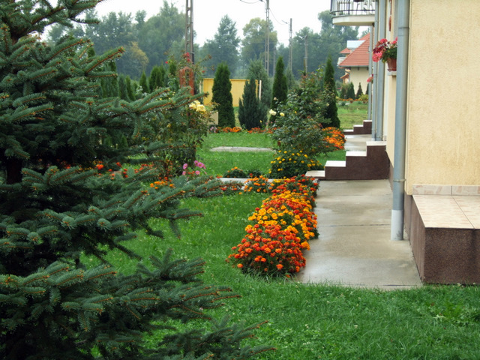
’Vándorbab’ Suite buildings’ front garden

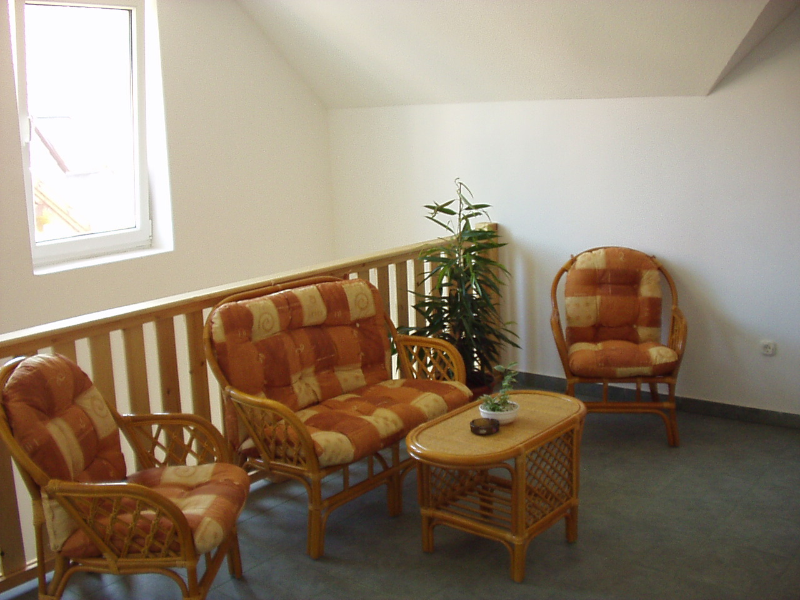
’Vándorbab’ Suite building loft lounge

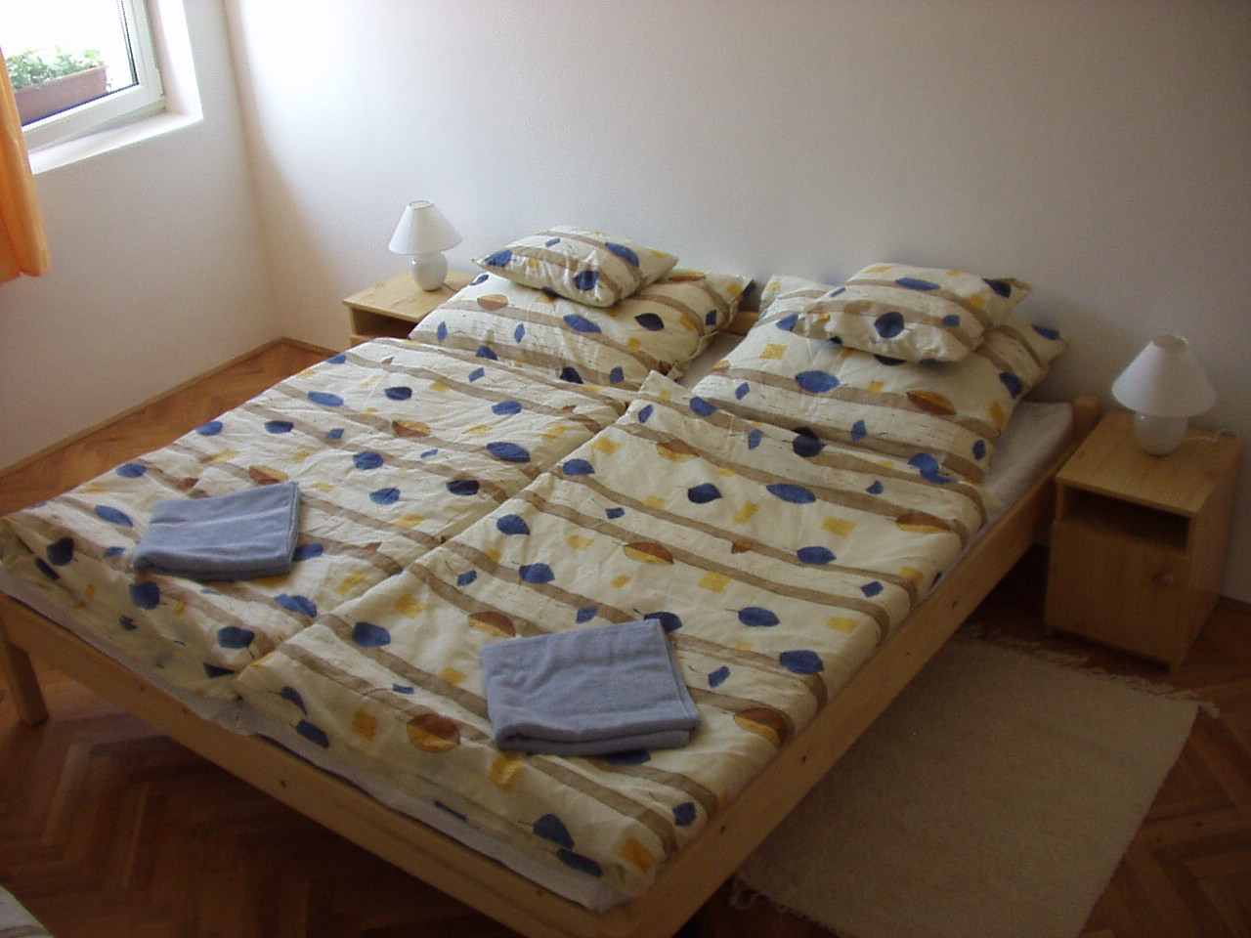
’Vándorbab’ Suite building first floor bedroom

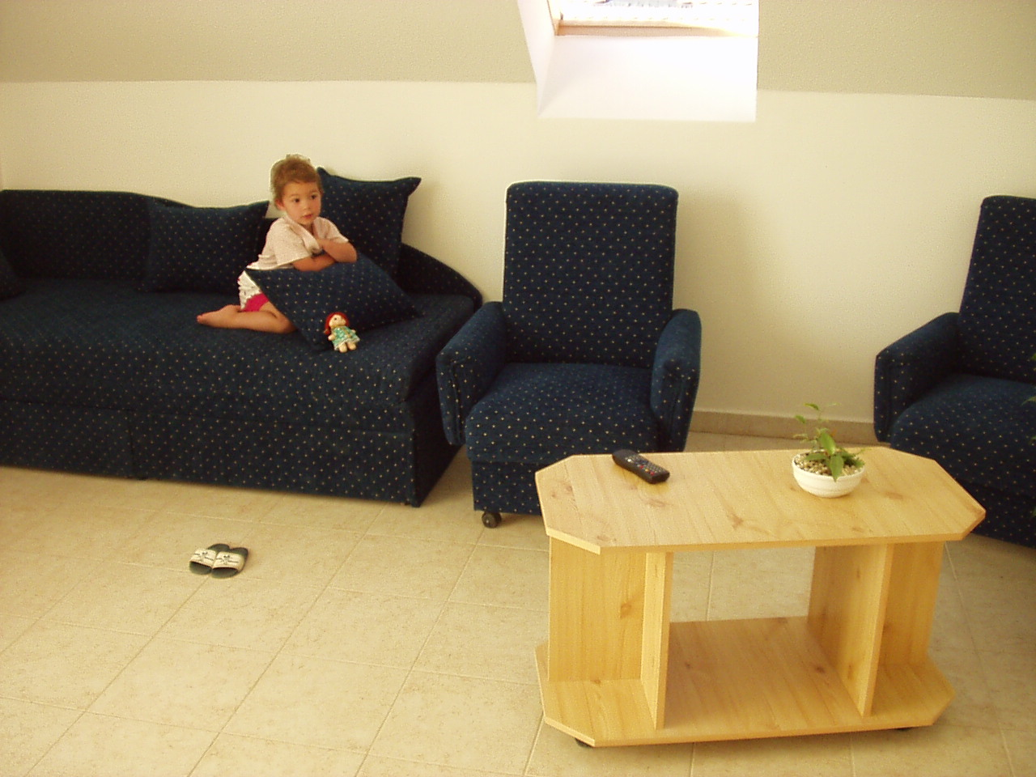
’Vándorbab’ Suite building first floor living room

’Vándorbab’ Suite building first floor bathroom
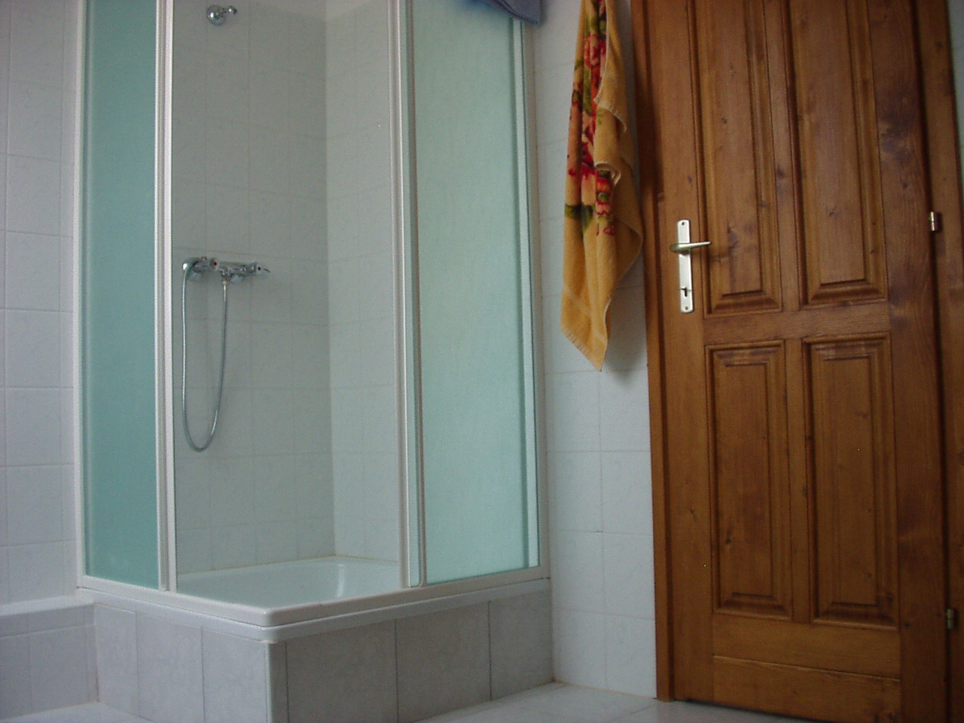
’Vándorbab’ Suite building first floor bathroom

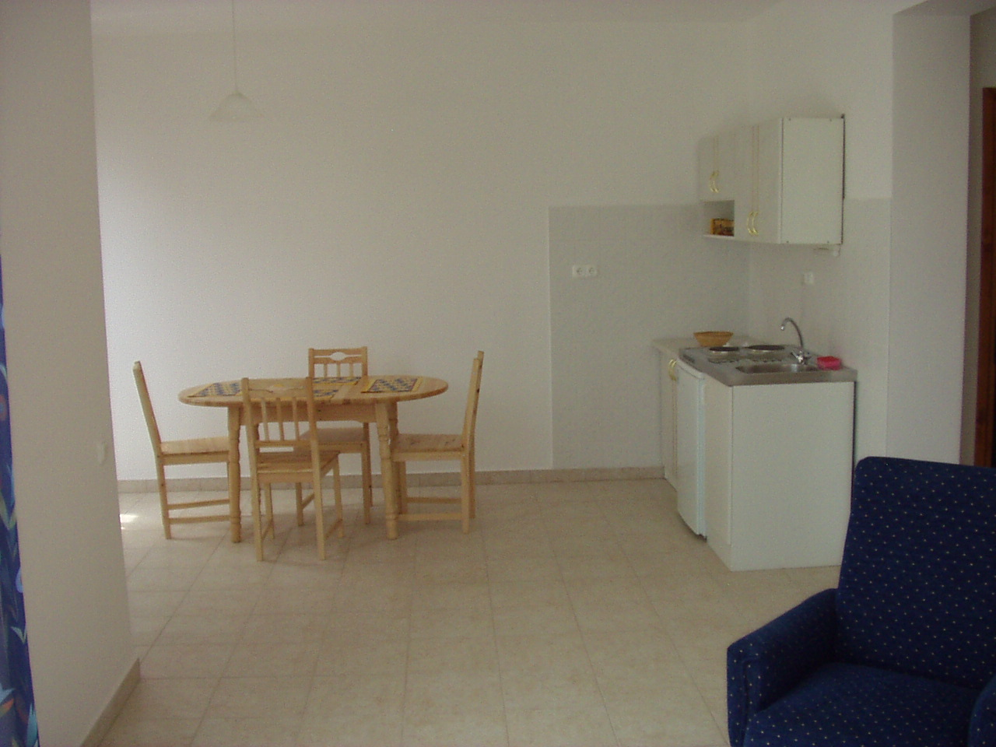
’Vándorbab’ Suite building ground floor kitchen

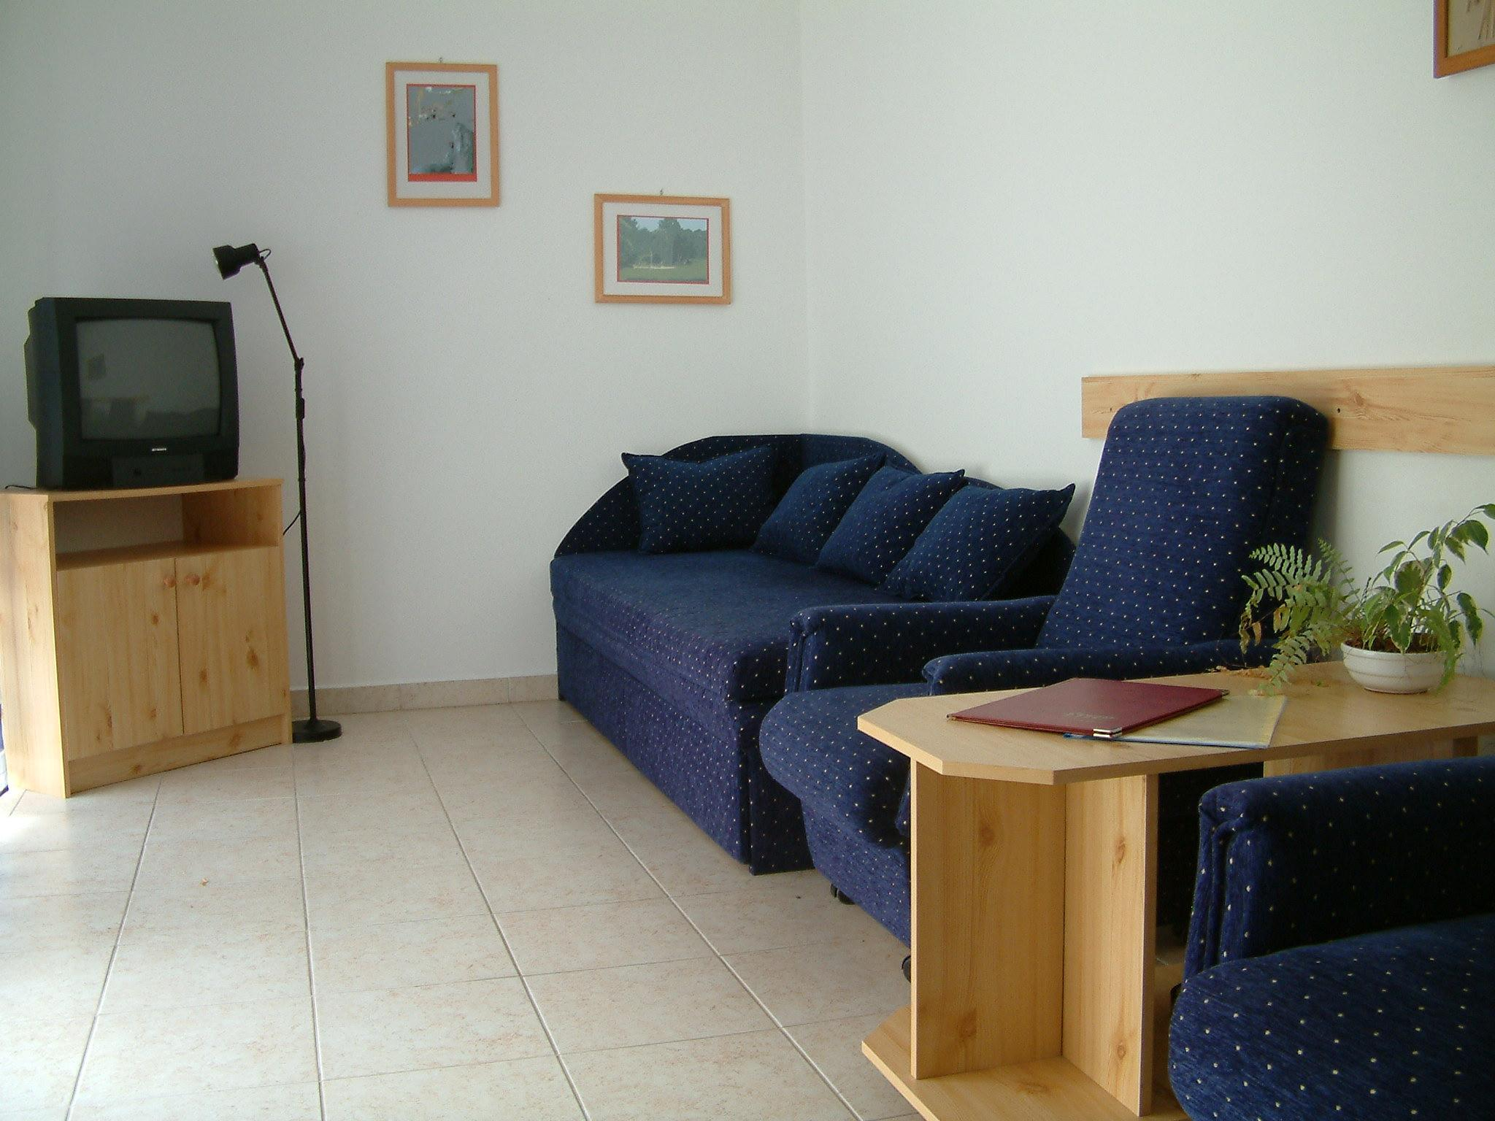
’Vándorbab’ Suite building ground floor living room

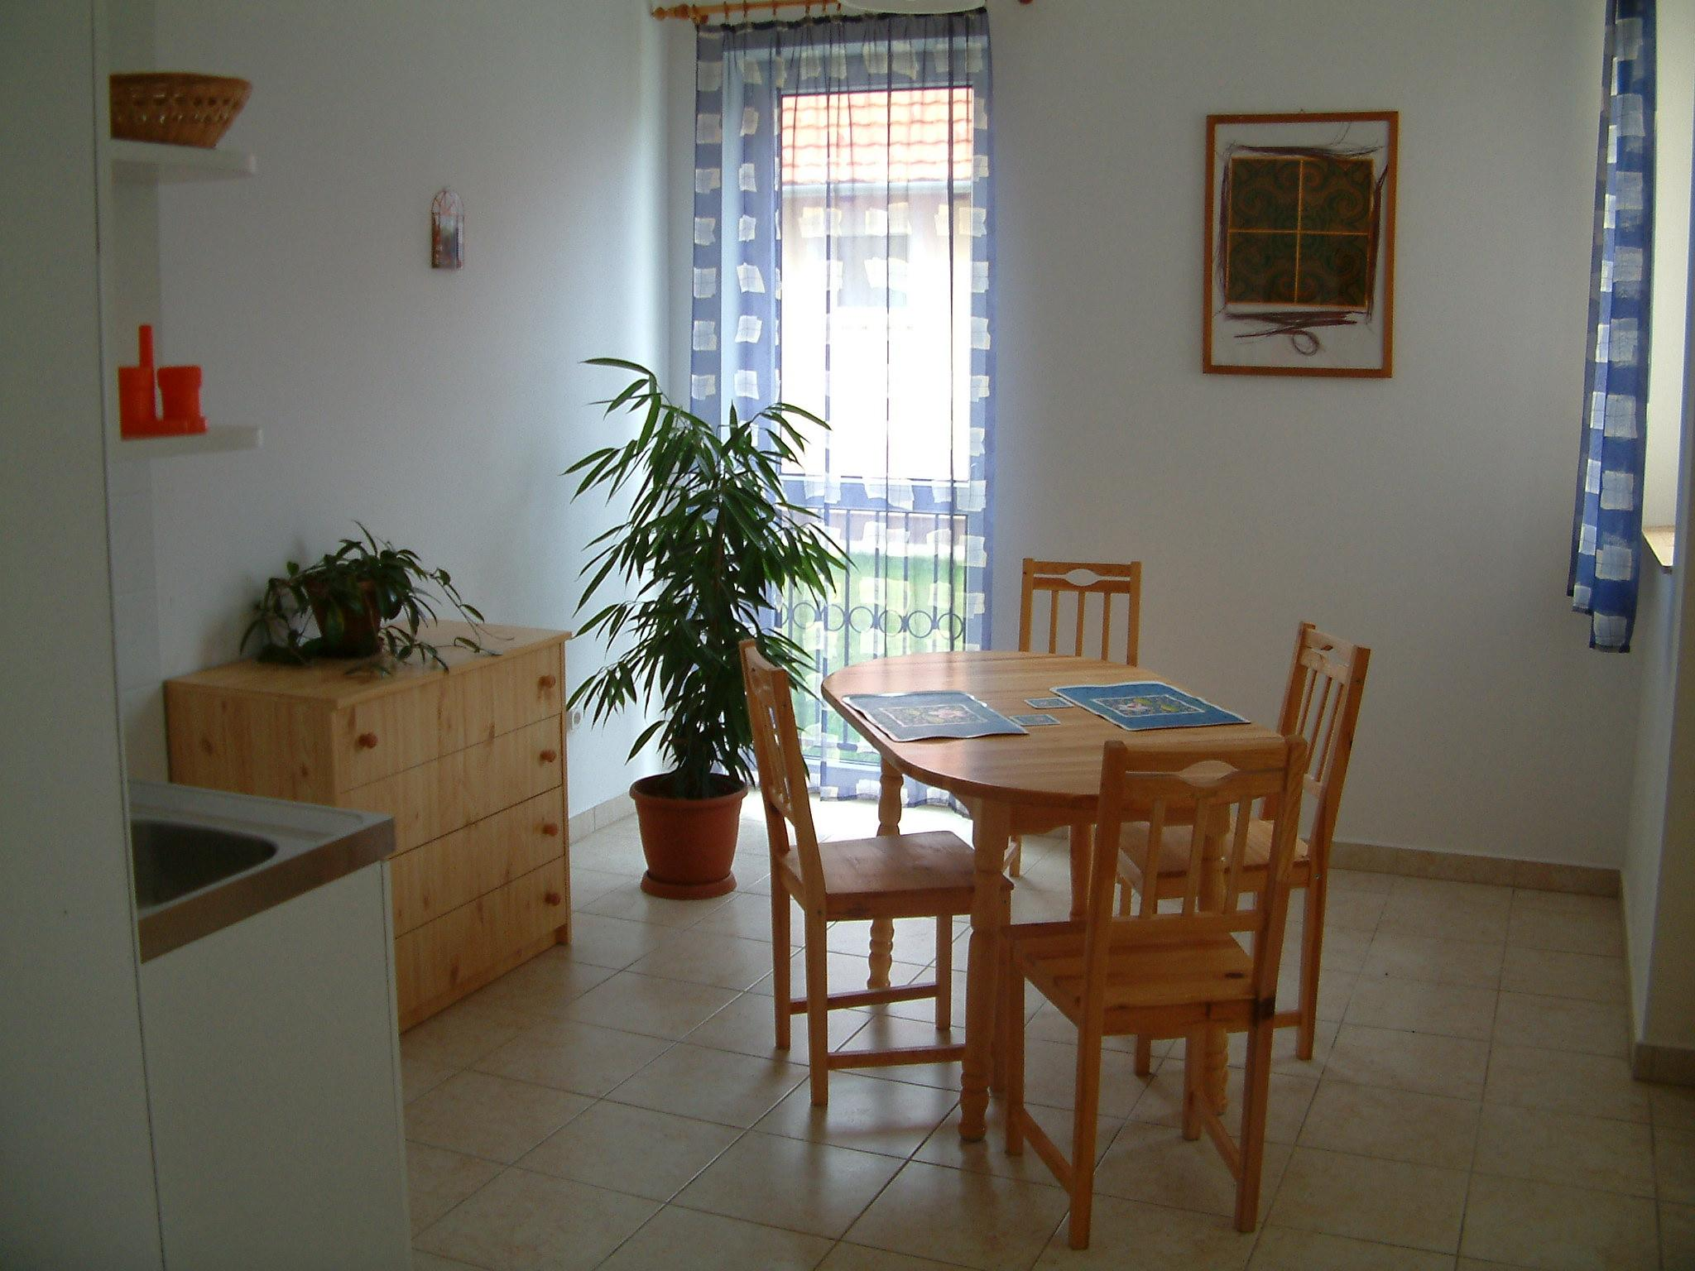
’Vándorbab’ Suite building ground floor dining room
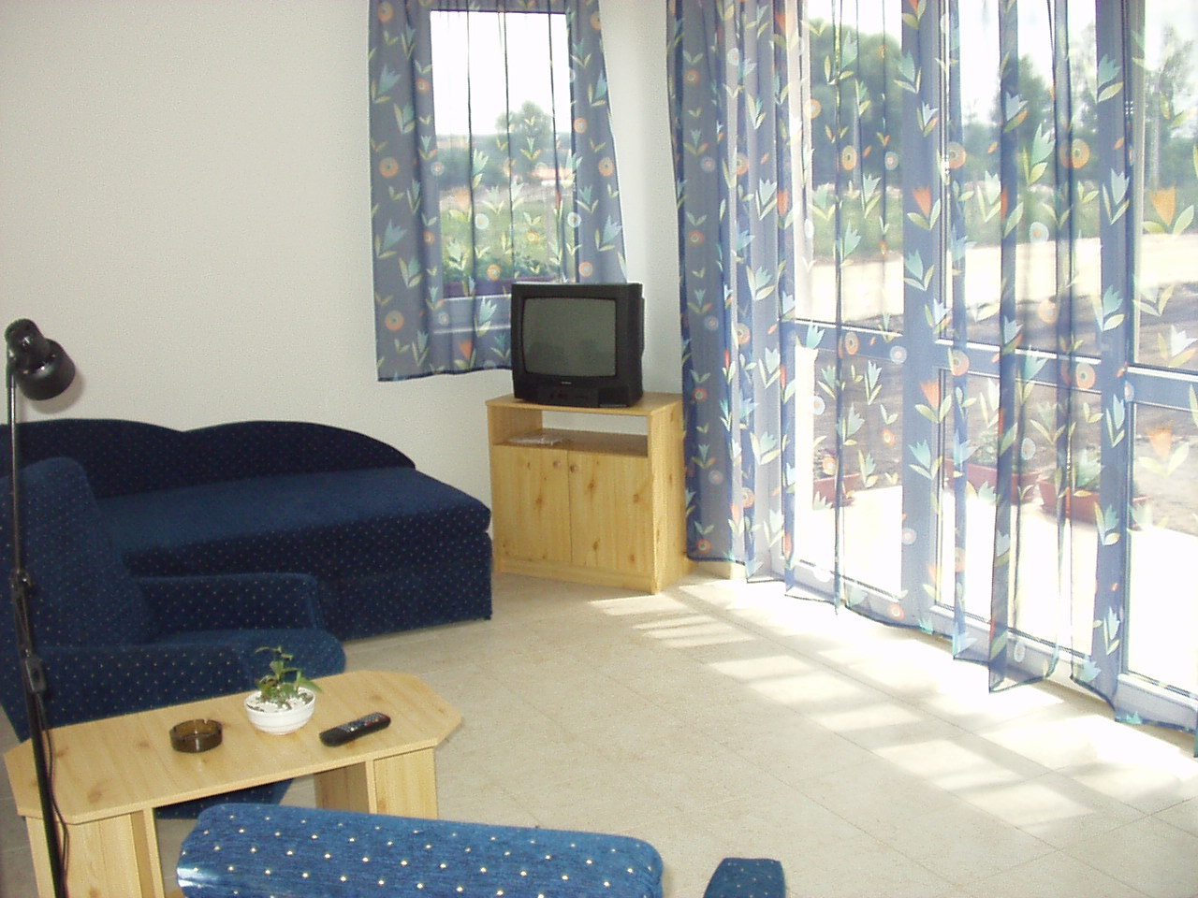
’Vándorbab’ Suite building ground floor living room

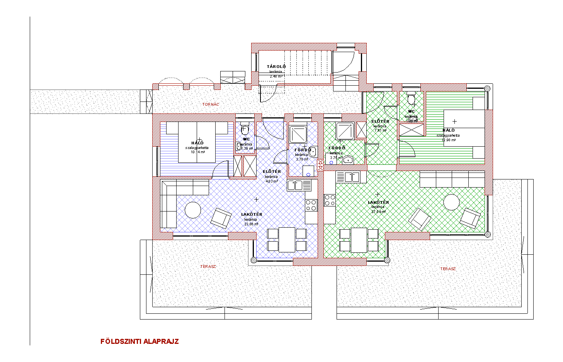

’Vándorbab’ Suite buildings’ layout (ground floor)

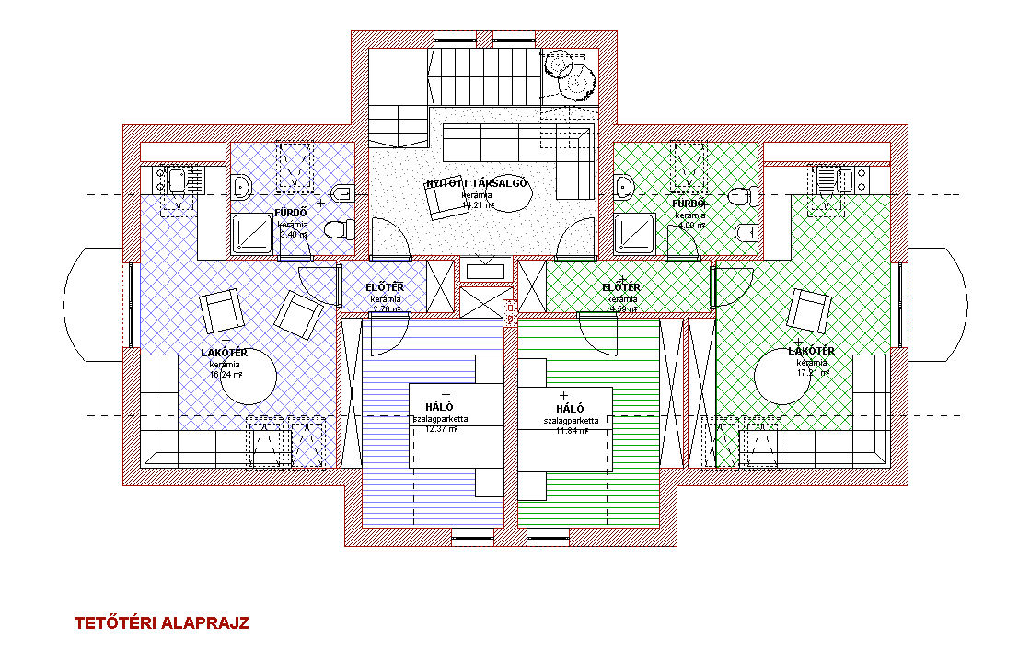

’Vándorbab’ Suite buildings’ layout (first floor / loft)

